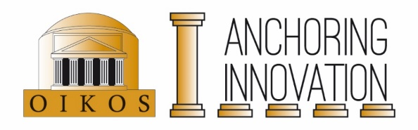
Anchoring Innovation Travel Grant

The Anchoring Innovation project provides travel grants for research that is directly related to the concept of Anchoring Innovation. All OIKOS members with a master’s or higher degree can submit a grant proposal via this form. PhDs and postdocs from the Anchoring Innovation project are expected to first use their personal budget.

The grant covers costs up to €1000,-. Grants are paid afterwards and only if the costs can be accounted for by official receipts and if a short report (about 200 words) is submitted (which includes the output of the trip, such as lectures and articles) at anchoring@let.ru.nl.

Proposals can be submitted year round via anchoring@let.ru.nl. Grants are awarded three times a year: around 1 April, 1 September and 1 December. The Anchoring Innovation Travel Committee consists of Prof. C.H.M. Kroon and Prof. O.M. van Nijf. Please submit your application well in advance of your intended travel!
------------------------------------------------------------------------------------------------------------------------

Date:

Name:

Affiliation:

(Anchoring) Project:

Total amount requested:

Purpose:

Period of travel:

Motivation (brief explanation of the value of your travel for the Anchoring-project):

Budget (please also indicate possible other financial sources):

please do not write here

Voor interne administratie:

Toekennen/ afwijzen

Datum besluit:

Opmerkingen:

Associated members and research master students cannot apply.

