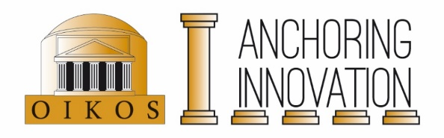
Anchoring Innovation Travel Grant

The Anchoring Innovation project provides travel grants for research that is directly related to the concept of Anchoring Innovation. All OIKOS members with a master’s or higher degree can submit a grant proposal via this form. PhDs and postdocs from the Anchoring Innovation project are expected to first use their personal budget.

The grant covers costs up to €1000,-. Grants are paid afterwards and only if the costs can be accounted for by official receipts and if a short report (300-400 words) is submitted (which includes the output of the trip, such as lectures and articles) at anchoring@let.ru.nl. The report can also serve as the basis for a short travel report for the Anchoring Innovation website.

Proposals can be submitted via anchoring@let.ru.nl. The Anchoring Innovation Travel Committee consists of Prof. C.H.M. Kroon and Prof. O.M. van Nijf. Please submit your application well in advance of your intended travel. The applications are assessed four times a year: 1 January, 1 April, 1 July and 1 October.
------------------------------------------------------------------------------------------------------------------------

Date:

Name:

Affiliation:

(Anchoring) Project:

Total amount requested:

Purpose:

Period of travel:

Motivation (brief explanation of the value of your travel for the Anchoring-project):

Budget (please also indicate possible other financial sources):

please do not write here

Voor interne administratie:

Toekennen/ afwijzen

Datum besluit:

Opmerkingen:

Associated members and research master students cannot apply.

